NOR GATE
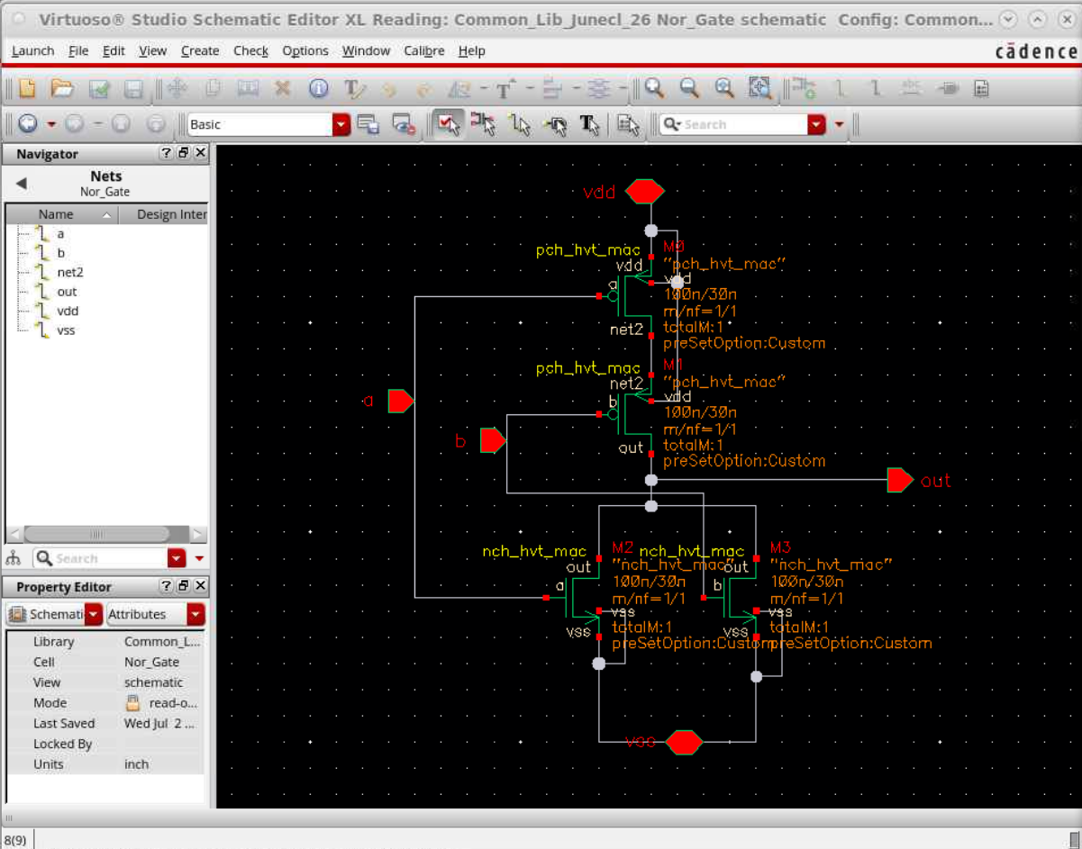
The above was the schematic given to me for NOR gate, and I had to make it using the DRM of TSMC 28nm technology.
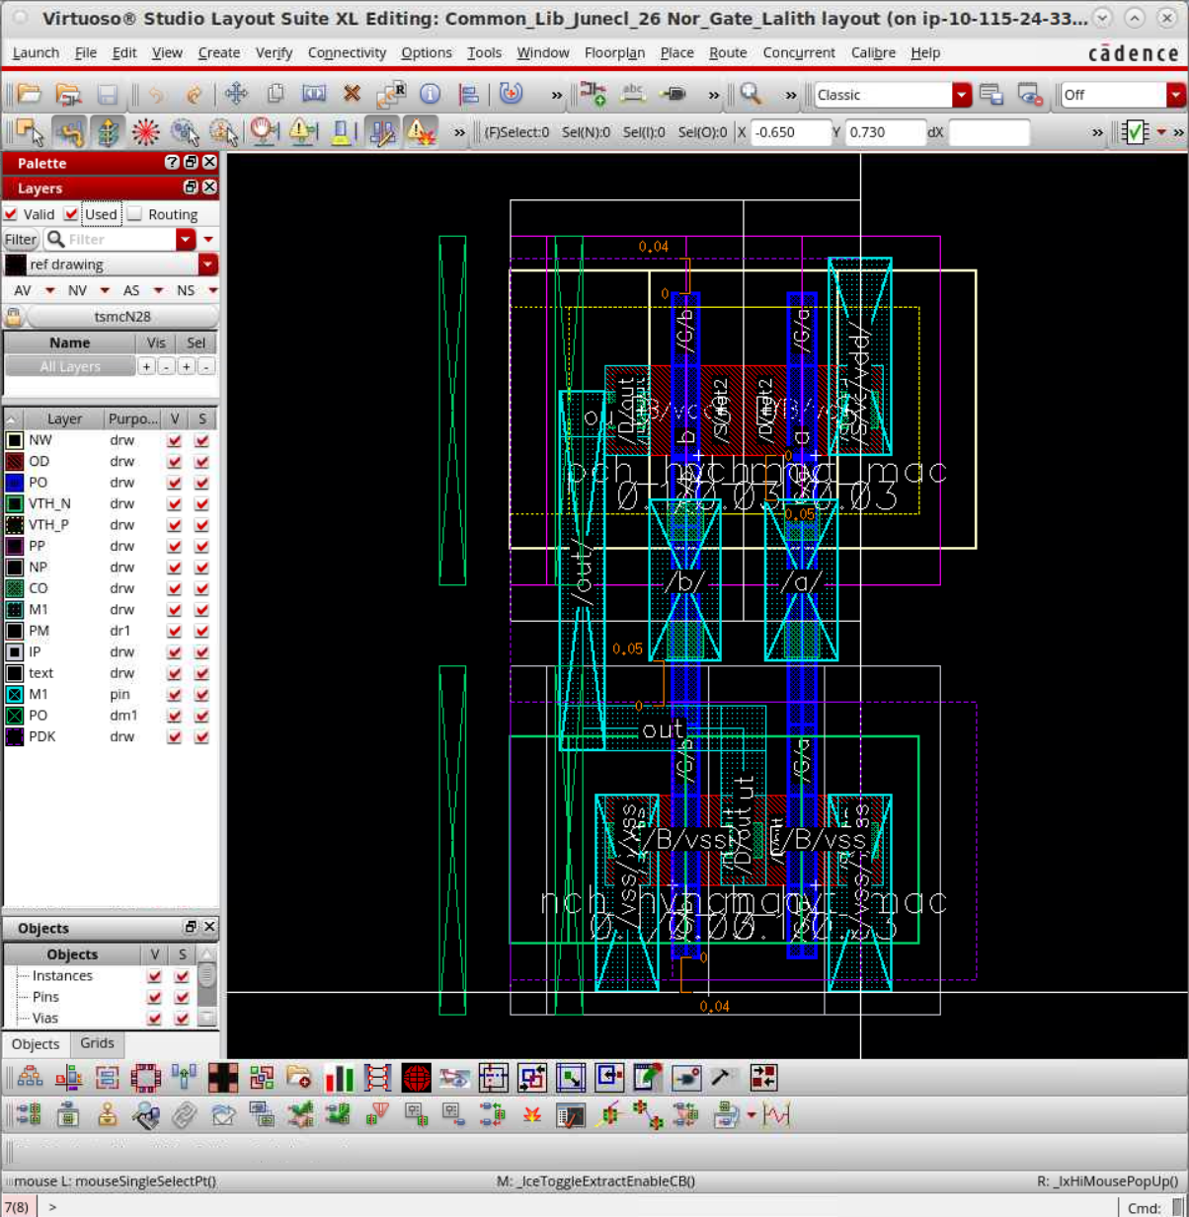
The above shows the layout I have made, optimising it in all ways possible, given by the DRM manual and on the left pane again, it shows the layers used and highlights them. This was made keeping in mind that it should be connected to the inverter in the XNOR design ultimately on the top level. This Design upon placing the Bulks is again LVS verified and ERC verified. The DRC check:
